1) How to see permission given on a specific folder or file?

Ans:

What does this mean ?
First represents a regular file. It gives you a hint of the type of object it is. It can have following values.
- d (directory)
- c (character device)
- l (symlink)
- p (named pipe)
- s (socket)
- b (block device)
- D (door)
- - (regular file)
represents read permission.
represents write permission and
represents executable permission.
First combination of rwx represents permission for the owner.
Second combination of rwx represents permission for the group.
Third combination of rwx represents permission for the other of the file.
Octal notation
Permission of file can also be represented in octal notation.
In octal notation
Read or r is represented by 4,
Write or w is represented by 2
Execute x is represented by 1.
Sum of these three is use to represent the permission.
stat command can be used to view file permission in octal notation
stat -c "%a %n" /path/of/file
For example
stat -c "%a %n" acroread
755 acroread
Here you can see
For owner it is 4+2+1=7 (111 in binary)
For group it is 4+0+1=5 (101 in binary) and
For other it is 4+0+1=5 (101 in binary).

Output:

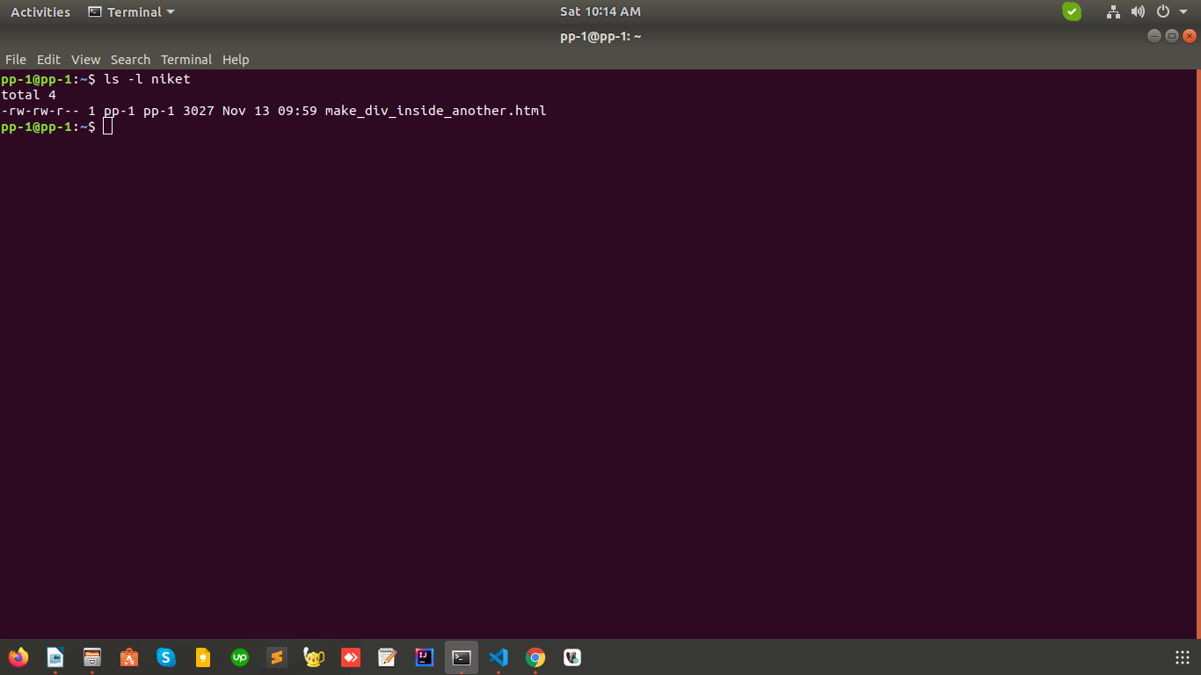

2) How To change permission of any folder or file ?

Ans:

Here i have changed the permission to 777 ,to change permission of any file write the command in terminal chmod -R 777 directory name.

Other permission are:

- chmod +rwx filenme to add permissions.
- chmod -rwx directoryname to remove permissions.
- chmod +x filename to allow executable permissions.
- chmod -wx filename to take out write and executable permissions.
Note that “r” is for read, “w” is for write, and “x” is for execute.

These are the Permission numbers
- 0 = ---
- 1 = --x
- 2 = -w-
- 3 = -wx
- 4 = r-
- 5 = r-x
- 6 = rw-
- 7 = rwx
Output:
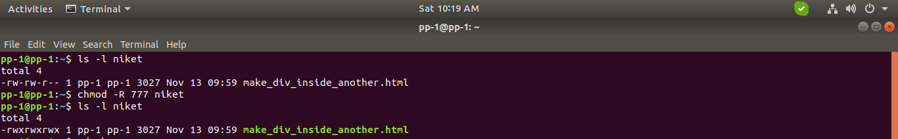

Refrences

https://askubuntu.com/questions/528411/how-do-you-view-file-permissions
https://stackoverflow.com/questions/8328481/chmod-777-to-a-folder-and-all-contents

